TITLE. TITLE. TITLE. TITLE.
TITLE. TITLE. TITLE.
TITLE. TITLE. TITLE. TITLE. TITLE.
TITLE. TITLE.

STUDENT’S NAME
Master of Science/Doctor of Philosophy
UNIVERSITI MALAYSIA PAHANG
AL-SULTAN ABDULLAH
UNIVERSITI MALAYSIA PAHANG AL-SULTAN ABDULLAH
DECLARATION OF THESIS AND COPYRIGHT

I declare that this thesis is classified as:

I acknowledge that Universiti Malaysia Pahang Al-Sultan Abdullah reserves the following
rights:

1. The Thesis is the Property of Universiti Malaysia Pahang Al-Sultan Abdullah
2. The Library of Universiti Malaysia Pahang Al-Sultan Abdullah has the right to make copies of the thesis for the purpose of research only.
3. The Library has the right to make copies of the thesis for academic exchange.

Certified by:

NOTE : * If the thesis is CONFIDENTIAL or RESTRICTED, please attach a thesis declaration letter.

THESIS DECLARATION LETTER (OPTIONAL)
Librarian,
Universiti Malaysia Pahang Al-Sultan Abdullah,
Lebuh Persiaran Tun Khalil Yaakob,
26300, Gambang, Kuantan, Pahang.

Dear Sir,

CLASSIFICATION OF THESIS AS RESTRICTED

Please be informed that the following thesis is classified as RESTRICTED for a period of three (3) years from the date of this letter. The reasons for this classification are as listed below.

Author’s Name
Thesis Title
Reasons | (i)
 | (ii)
 | (iii)

Thank you.

Yours faithfully,

_____________________________
(Supervisor’s Signature)

Date:

Stamp:

Note: This letter should be written by the supervisor and addressed to the Librarian, Universiti Malaysia Pahang Al-Sultan Abdullah with its copy attached to the thesis.

SUPERVISOR’s DECLARATION
I/We* hereby declare that I/We* have checked this thesis/project* and in my/our* opinion, this thesis/project* is adequate in terms of scope and quality for the award of the degree of *Doctor of Philosophy/ Master of Science.

_______________________________
(Supervisor’s Signature)
Full Name :
Position :
Date :

_______________________________
(Co-supervisor’s Signature)
Full Name :
Position :
Date :
STUDENT’S DECLARATION
I hereby declare that the work in this thesis is based on my original work except for quotations and citations which have been duly acknowledged. I also declare that it has not been previously or concurrently submitted for any other degree at Universiti Malaysia Pahang Al-Sultan Abdullah or any other institutions.

_______________________________
(Student’s Signature)
Full Name : AHMAD MUSTAQIM BIN MOHD ZULI
ID Number : 201344899
Date : 12 October 2016

TITLE
TITLE
TITLE
TITLE
STUDENT’S NAME
Thesis submitted in fulfillment of the requirements
for the award of the degree of
Doctor of Philosophy/Master of Science
Faculty of Electrical and Electronics Engineering Technology
UNIVERSITI MALAYSIA PAHANG AL-SULTAN ABDULLAH
OCTOBER 2015

ACKNOWLEDGEMENTS
On the Insert tab, the galleries include items that are designed to coordinate with the overall look of your document. You can use these galleries to insert tables, headers, footers, lists, cover pages, and other document building blocks. When you create pictures, charts, or diagrams, they also coordinate with the current look of your document.
You can easily change the formatting of a selected text in the document text by choosing a look for the selected text from the Quick Styles gallery on the Home tab. You can also format the text directly by using the other controls on the Home tab. Most controls offer the option of either using the look from the current theme or using a format that you specify directly.
To change the overall look of your document, choose new theme elements on the Page Layout tab. To change the looks available in the Quick Styles gallery, use the Change Current Quick Style Set command. Both the Themes gallery and the Quick Styles gallery have reset commands so that you can always restore the look of your document to the original one in your current template.

ABSTRAK
You can easily change the formatting of a selected text in the document text by choosing a look for the selected text from the Quick Styles gallery on the Home tab. You can also format the text directly by using the other controls on the Home tab. Most controls offer the option of either using the look from the current theme or using a format that you specify directly.
Mmjmjm
Mjmjmj
hhhh

ABSTRACT
You can easily change the formatting of a selected text in the document text by choosing a look for the selected text from the Quick Styles gallery on the Home tab. You can also format the text directly by using the other controls on the Home tab. Most controls offer the option of either using the look from the current theme or using a format that you specify directly.

TABLE OF CONTENT
DECLARATION
TITLE PAGE
ACKNOWLEDGEMENTS ii
ABSTRAK iii
ABSTRACT iv
TABLE OF CONTENT v
LIST OF TABLES vii
LIST OF FIGURES viii
LIST OF SYMBOLS ix
LIST OF ABBREVIATIONS x
LIST OF APPENDICES xi
CHAPTER 1 INTRODUCTION 1
1.1 UMP Thesis Template 1
1.2 Developer Tab 1
1.2.1 Navigation Pane 2
1.2.2 Styles Function 3
1.3 Summary 9
CHAPTER 2 STYLES 10
2.1 Heading 1 10
2.2 Heading 2 10
2.2.1 Heading 3 10
2.3 Other important styles 11
2.3.1 Another equally important style is the caption. All captions for figures, tables and equations are formatted using their respective styles prepared in this template. 11
2.4 Equations 11
2.5 Quotes 11
2.6 Table 12
CHAPTER 3 METHODOLOGY 14
3.1 Introduction 14
CHAPTER 4 RESULTS AND DISCUSSION 15
4.1 Introduction 15
CHAPTER 5 CONCLUSION 16
5.1 Introduction 16
REFERENCES 17
APPENDICES 18

LIST OF TABLES
Table ‎1.1 Title 1
Table ‎1.2 Title 7
Table ‎1.3 Title new 8
Table ‎2.1 Sample table 1 12
Table ‎2.2 Sample table 2 To allow for greater flexibility, this template includes another two types of styles for formatting tables, named Table text center and Table header center 12

LIST OF FIGURES
Figure ‎1.1 Enabling the Developer Tab 2
Figure ‎1.2 Navigation Pane 3
Figure ‎1.3 Enabling the Styles pane 5
Figure ‎1.4 Styles pane on the right side of the window, listing all recommended styles for selection 6

LIST OF SYMBOLS
LIST OF ABBREVIATIONS
SBPWM | Simple Boost Pulse Width Modulation
ZSI | Z source inverter

LIST OF APPENDICES
Appendix A: Title 19
Appendix B: Title 20

INTRODUCTION

UMP Thesis Template
Thesis formatting has long been one of the nightmares for postgraduate students. More often than not, students find themselves spending more time than expected just to format their thesis. Starting from 2016, Universiti Malaysia Pahang (UMP) provides Microsoft Word template of the thesis format to UMP postgraduates. This module aims to guide users (both postgraduates and undergraduates) to effectively use the template. The module has been written with step-by-step instructions, accompanied with appropriate diagrams. Its design is aimed at facilitating users with self-practice on the computer simultaneously. (Crooks & Alibali, 2014)
This document is a template created to ease the thesis writing process. The file is in .dotx extension, a dedicated file extension for creating a template in Microsoft Word. Before this template can be applied to your document, it is important that you should enable several Microsoft Word features first.
Table 1.1 Title
Test | Text
Test | Text
Test | Text
Test | Text
Test | Text

Developer Tab
To create a new Microsoft Word document for your thesis based on this .dotx template, just double click the file. A new document will open in Microsoft Word, normally named Untitled.docx or Document1.docx. You can start writing your content in that file without having to worry about thesis formatting. However, if you want to apply this .dotx template to your current thesis, you need to enable the Developer Tab option first. To do this, see Figure 1.1.
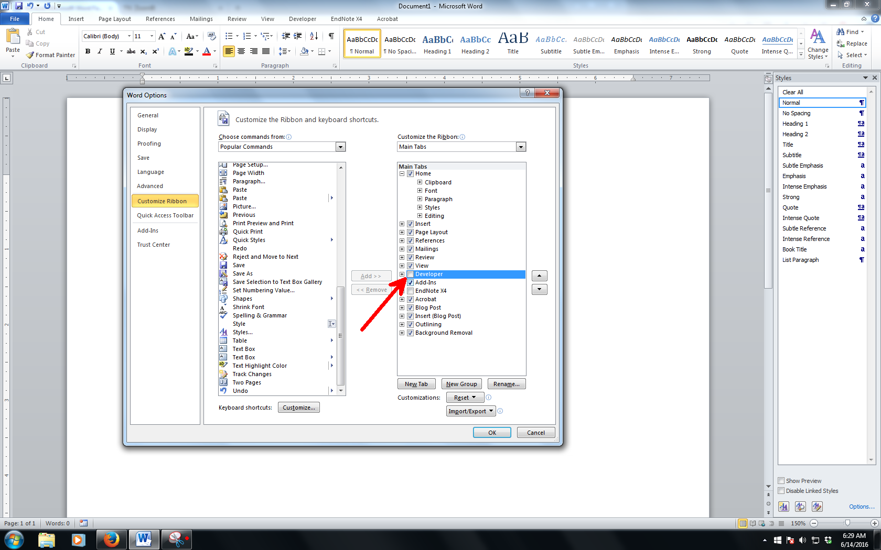
Figure 1.1 Enabling the Developer Tab
Source: Alexandrov & Alexandrov (2015). Use style named Citation for Figure UMP for any text here.
Developer Tab will allow you to apply this .dotx template onto any Microsoft Word document files.

Navigation Pane
Navigation Pane is where you can browse through your thesis based on its heading name. To enable it, see Figure 1.2.
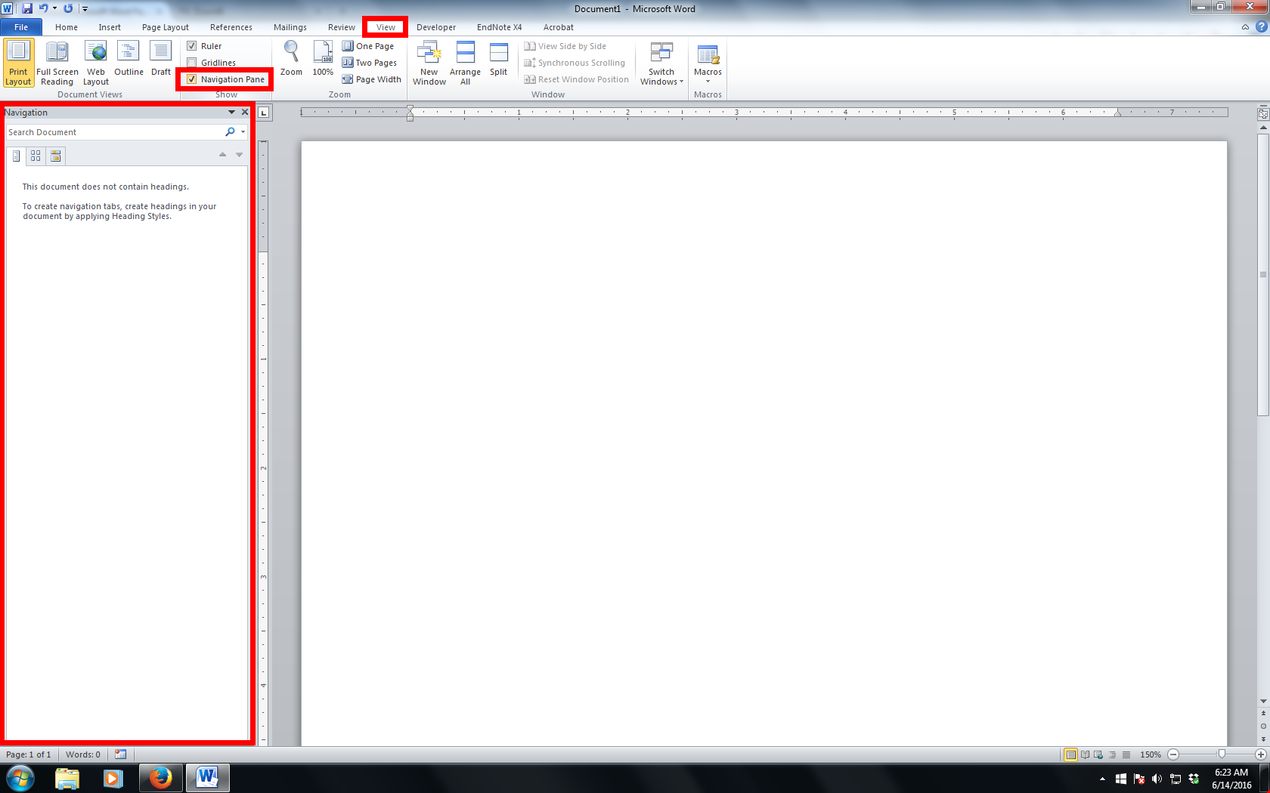
Figure 1.2 Navigation Pane
As shown in Figure 1.2, the option to enable navigation pane resides in View ribbon.

Styles Function
The basis of applying any given template is controlled by the Styles function. This function enables the formatting of texts and paragraphs to be predefined. It is suggested that the Styles pane is placed on the right side of the Microsoft Word working environment so that you can work through the entire thesis formatting and writing most efficiently. This can be done by clicking a small arrow as shown in Figure 1.3. If your pane appears to be floating, click and hold the window and place it on the right side of the window.
            - On the Insert tab, the galleries include items that are designed to coordinate with the overall look of your document.
            - You can use these galleries to insert tables, headers, footers, lists, cover pages, and other document building blocks.
            - When you create pictures, charts, or diagrams, they also coordinate with your current document look.
              - You can easily change the formatting of selected text in the document text by choosing a look for the selected text from the Quick Styles gallery on the Home tab.
              - You can also format text directly by using the other controls on the Home tab.
              - Most controls offer a choice of using the look from the current theme or using a format that you specify directly.

                - On the Insert tab, the galleries include items that are designed to coordinate with the overall look of your document. You can use these galleries to insert tables, headers, footers, lists, cover pages, and other document building blocks.
When you create pictures, charts, or diagrams, they also coordinate with your current document look. You can easily change the formatting of selected text in the document text by choosing a look for the selected text from the Quick Styles gallery on the Home tab.

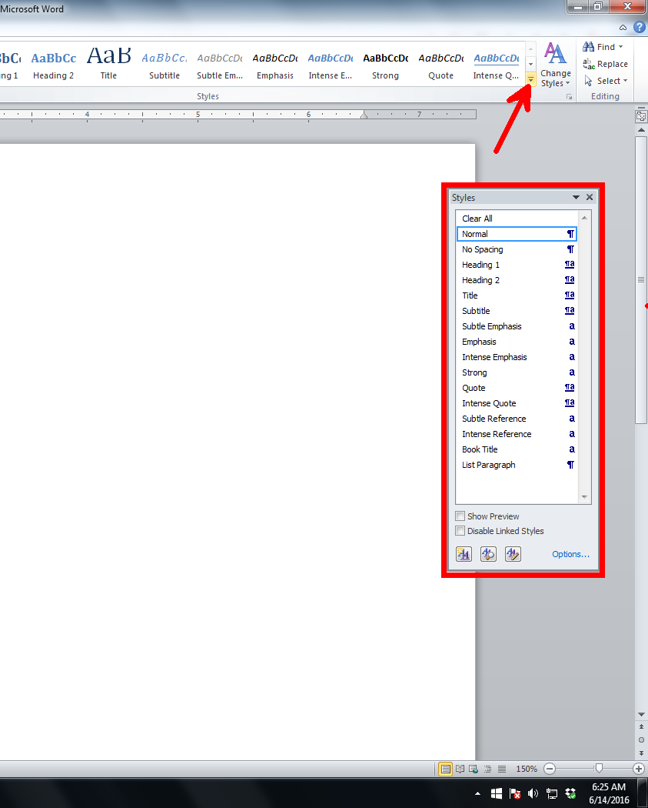
Figure 1.3 Enabling the Styles pane
Once it has been secured on the right side of the Microsoft Word working environment, the Styles pane should be able to show the predefined formatted texts and paragraphs (see Figure 1.4).
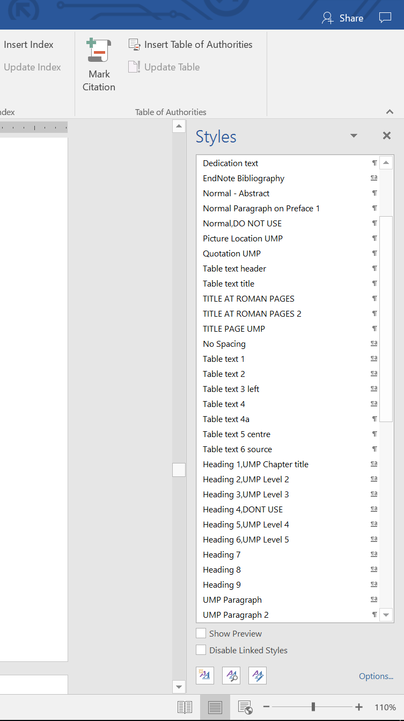
Figure 1.4 Styles pane on the right side of the window, listing all recommended styles for selection
On the Insert tab, the galleries include items that are designed to coordinate with the overall look of your document. On the Insert tab, the galleries include items that are designed to coordinate with the overall look of your document.
Table 1.2 Title
Test | Text
Test | Text
Test | Text
Test | Text
Test | Text

Table 1.3 Title new
Tile | Identity | Gender | Location | Sample
Enabling the styles pane will allow faster and easier thesis formatting. To make sure the title is continue from the previous pages, use TAB Layout / Repeat Header Rows.

Summary
This chapter introduces users to the UMP Microsoft Word Thesis Template in .dotx format and the basic features of Microsoft Word that need to be enabled first before the .dotx template can be used. Once these important features have been enabled, your computer should be ready, and the template can now be applied to your document. You can familiarize yourself with the styles used in this .dotx template. Some of the styles will be explained further in Chapter 2.

STYLES

Heading 1
Heading 1 is used in naming each chapter. In this template, it is called Heading 1, UMP Chapter Title. In most cases, a thesis will usually have between five and seven chapters.
(Gertler, 2003)

Heading 2
The style used for this subchapter 2.2 is Heading 2, UMP Level 2.

Heading 3
The heading for Subchapter 2.2.1 is formatted with Heading 3, UMP Level 3.

Heading 5
In this template, style Heading 4 is not used. Instead, the heading for level 4 will be using the style Heading 5, UMP Level 4. These are all the heading styles needed to format a thesis.

Heading 6
UMP Level 5 subsection will be headed using Heading 6 style. It is not numbered as other headings.

Other important styles
All styles developed in this template are essential to ensure proper formatting of a thesis. The most widely used style is UMP Paragraph. This paragraph style is formatted by UMP Paragraph syles.

Another equally important style is the caption. All captions for figures, tables and equations are formatted using their respective styles prepared in this template.

Equations
As shown in Equation 2.1, all equations must be systematically numbered. To insert any equation, copy the whole equation and numbering as shown below and paste them on the desired location. Then, edit the equation. The style used for equation is Caption for Equation UMP.
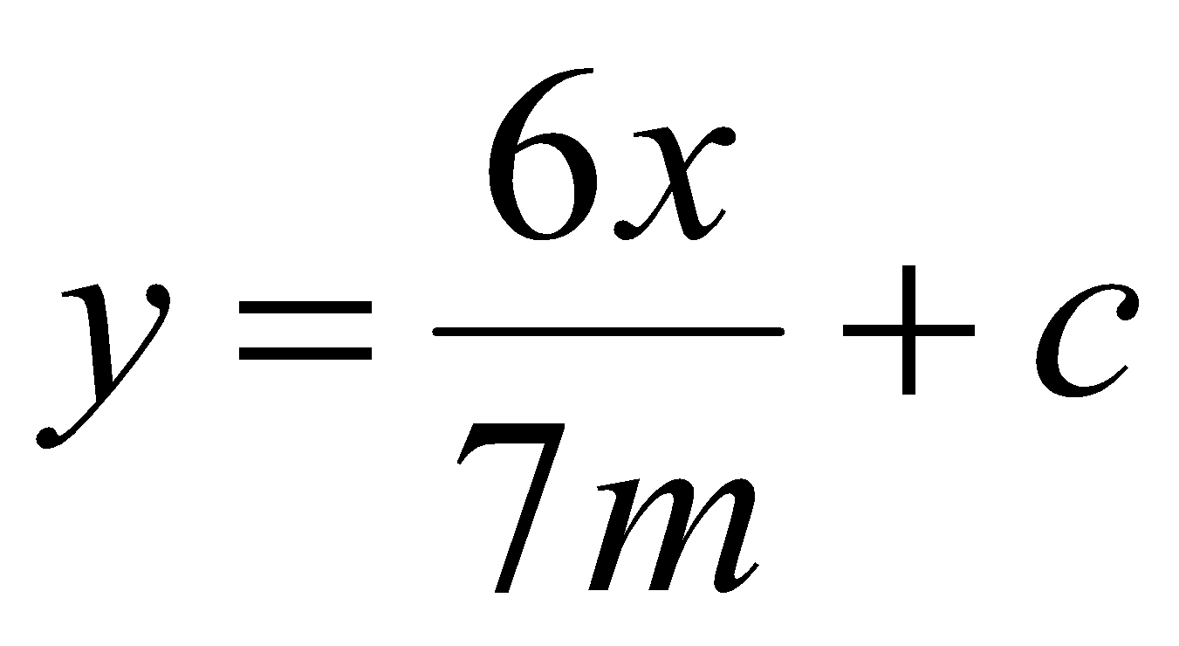 | 2.1
The paragraph that comes after an equation of a figure, has to be formatted using UMP Paragraph 2. This is to allow some space between the paragraph and the caption of the equation or the figure. This paragraph uses UMP Paragraph 2 style.

Quotes
In any case that a writer needs to quote 40 or more words, block quotation should be used. To insert a block quotation, use Quotation UMP style. All quotations must be properly cited to avoid plagiarism.
On the Insert tab, the galleries include items that are designed to coordinate with the overall look of your document. You can use these galleries to insert tables, headers, footers, lists, cover pages, and other document building blocks. When you create pictures, charts, or diagrams, they also coordinate with the current look of your document. You can easily change the formatting of a selected text in the document text by choosing a look for the selected text from the Quick Styles gallery on the Home tab. You can also format the text directly by using the other controls on the Home tab. Most controls offer the option of either using the look from the current theme or using a format that you specify directly.
However, if a quotation is short, in text quotation should be used.

Table
The text in the paragraph can be formatted using Table text style whereas the header is formatted using Table header style. Meanwhile, the style for caption is called Caption for Table UMP. Table 2.1 shows an example of properly formatted table.
Table 2.1 Sample table 1
Test | Text
Test | Text
Test | Text
Test | Text
Test | Text
Source: Rahman (2007). Use Citation for Table UMP style here.
If the table need citation, use the Citation for Table UMP style at the bottom of the table. To allow for greater flexibility, this template includes another two types of styles for formatting tables, named Table text center and Table header center.
Table 2.2 Sample table 2 To allow for greater flexibility, this template includes another two types of styles for formatting tables, named Table text center and Table header center
Test | Text
Test | Text
Test | Text
Test | Text
Test | Text
Test | Text
Test | Text
Test | Text
Test | Text

METHODOLOGY

Introduction

RESULTS AND DISCUSSION

Introduction

CONCLUSION

Introduction

REFERENCES
Use a reference manager such as Mendeley, EndNote or any reference manager software to generate all your list of references here. Once all the references are included then apply Caption for Reference style.
Alexandrov, N., & Alexandrov, V. (2015). Computational science research methods for science education at PG level. Procedia Computer Science, 51(1), 1685–1693. https://doi.org/10.1016/j.procs.2015.05.305
Crooks, N. M., & Alibali, M. W. (2014). Defining and measuring conceptual knowledge in mathematics. Developmental Review, 34(4), 344–377. https://doi.org/10.1016/j.dr.2014.10.001
Gertler, M. S. (2003). Tacit knowledge and the economic geography of context, or the undefinable tacitness of being (there). Journal of Economic Geography, 3(1), 75–99. https://doi.org/10.1093/jeg/3.1.75

APPENDICES
Appendix A:
Title

Appendix B: Title

